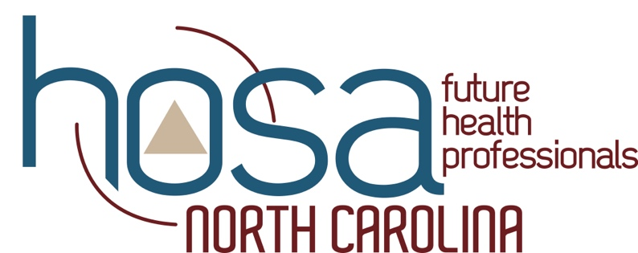

NC HOSA 2021 Virtual State Leadership Conference

Link: nchosa.live
(you may have to clear your cache for the link to work, you will receive an error message or see the Regional Leadership Conference landing page prior to 4/7/2021 at 3:00 PM)

Wednesday 4/7/2021
- 3:00pm-All Day, 60-minute at home workout
  - Get pumped at home using the free video from REFIT
- 3:00-All Day, Educational Symposia
  - Conference registrants have the opportunity to watch educational videos from various views of interest within healthcare
- 3:00-All Day, North Carolina HOSA Expo Hall
  - Check out the various vendors and sponsors of North Carolina HOSA as they share information about their contributions to healthcare and how you can become involved
- 4:00-6:00 Meet your North Carolina HOSA State Officers
  - Conference attendees have the opportunity to meet and talk to members of the North Carolina HOSA State Officer Team
Thursday 4/8/2021
- All Day, 60-minute at home workout
  - Get pumped at home using the free video from REFIT
- All Day, Educational Symposia
  - Conference registrants have the opportunity to watch educational videos from various views of interest within healthcare
- All Day, North Carolina HOSA Expo Hall
  - Check out the various vendors and sponsors of North Carolina HOSA as they share information about their contributions to healthcare and how you can become involved
- 3:00-5:00, Live Session, Opportunities within the Healthcare Environment, Hosted by St. Andrews University.
- 4:00-6:00 Meet your North Carolina HOSA State Officers
  - Conference attendees have the opportunity to meet and talk to members of the North Carolina HOSA State Officer Team
Friday 4/9/2021
- All Day, 60-minute at home workout
  - Get pumped at home using the free video from REFIT
- All Day, Educational Symposia
  - Conference registrants have the opportunity to watch educational videos from various views of interest within healthcare
- All Day, North Carolina HOSA Expo Hall
  - Check out the various vendors and sponsors of North Carolina HOSA as they share information about their contributions to healthcare and how you can become involved
- 4:00-6:00 Meet your North Carolina HOSA State Officers
  - Conference attendees have the opportunity to meet and talk to members of the North Carolina HOSA State Officer Team

Saturday 4/10/2021
- All Day, 60-minute at home workout
  - Get pumped at home using the free video from REFIT
- All Day, Educational Symposia
  - Conference registrants have the opportunity to watch educational videos from various views of interest within healthcare
- All Day, North Carolina HOSA Expo Hall
  - Check out the various vendors and sponsors of North Carolina HOSA as they share information about their contributions to healthcare and how you can become involved
- 10:00am-All Day, Recognition and Awards Session goes live

